

**Burger Shop**

Introduction

At Burger Shop, a love of good food, good people, and good times has always been at the heart of what we do. Launched in 2014, the concept was simple: to serve delicious, honest burgers, sides and drinks using quality ingredients at an affordable price. Our first 50-seat store in Ponsonby was a roaring success and the rest is history.

Technology

ASP.NET is a web development platform, which provides a programming model, a comprehensive software infrastructure and various services required to build up robust web applications for PC, as well as mobile devices.

ASP.NET works on top of the HTTP protocol, and uses the HTTP commands and policies to set a browser-to-server bilateral communication and cooperation.

ASP.NET is a part of Microsoft .Net platform. ASP.NET applications are compiled codes, written using the extensible and reusable components or objects present in .Net framework. These codes can use the entire hierarchy of classes in .Net framework.

The ASP.NET application codes can be written in any of the following languages:

* C#
* Visual Basic.Net
* Jscript
* J#

ASP.NET is used to produce interactive, data-driven web applications over the internet. It consists of a large number of controls such as text boxes, buttons, and labels for assembling, configuring, and manipulating code to create HTML pages.

Security System of the site

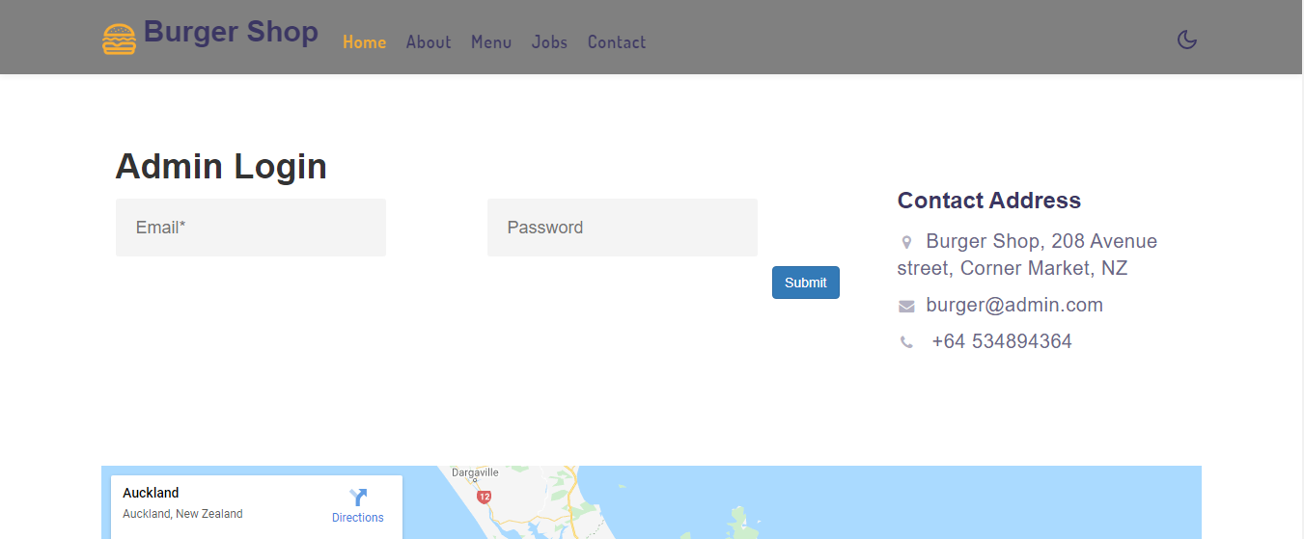

After Logging IN

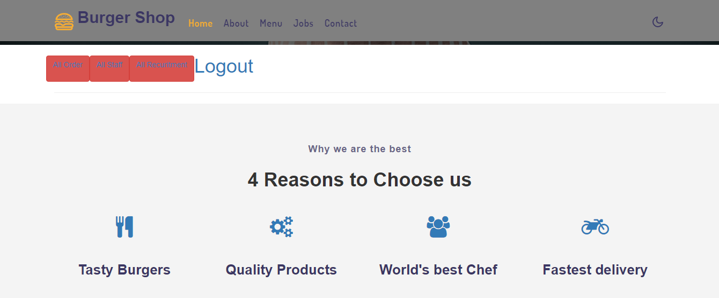

View Orders

Purpose

This page is to view all the orders that the restaurant will have

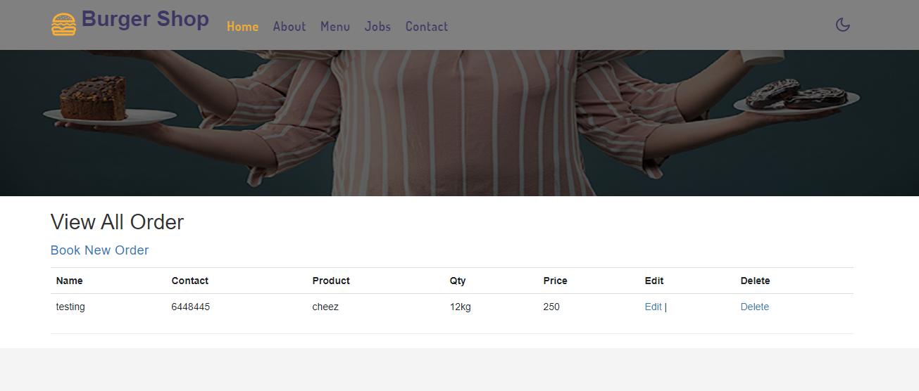

View staff member

Purpose

To take the record of the all members this page is very helpful

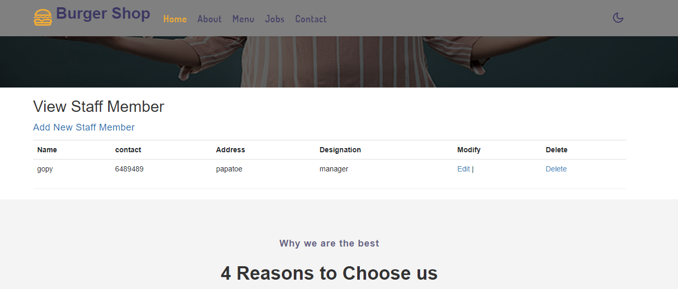

View Jobs

Purpose

Current going jobs can be added updated and deleted from this page

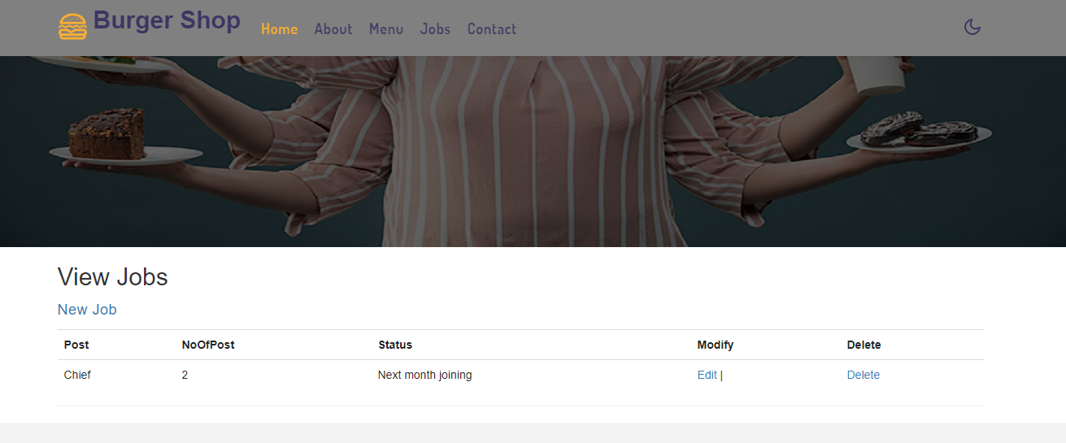

Show Jobs

Purpose

All jobs that are inserted in the database are shown here

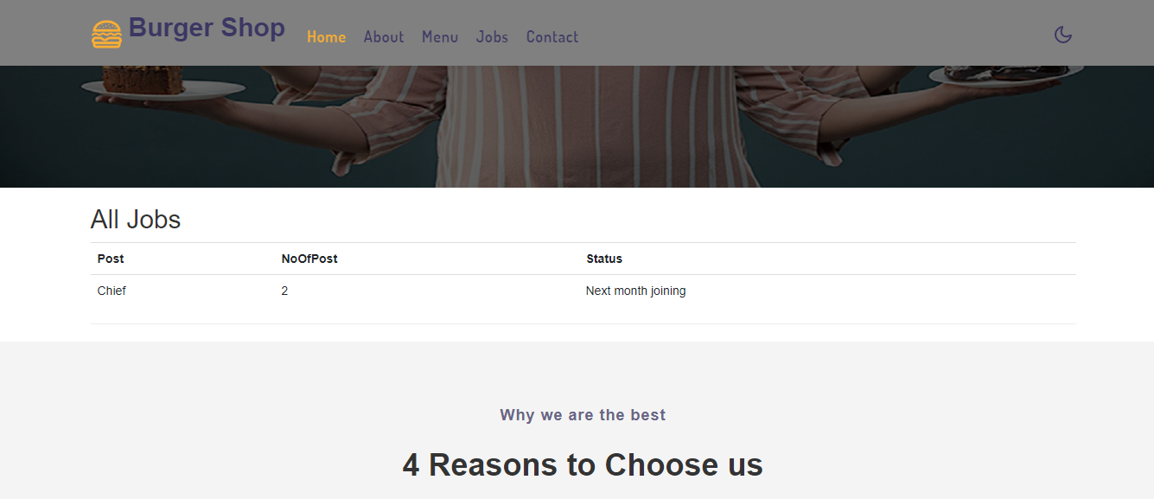

Contact

Contact page to add queries in data base

